How much should I plant?
Dr. Emily Glunk, Extension Forage Specialist
Dr. Jessica Torrion, Crop Physiologist
Depending on who you ask, you may get a wide range in how much seed you should be planting per acre. There are a lot of factors to consider, but in my experience, there are many producers throughout the nation that are spending more money, and putting more seed in the ground, than is necessary. There are some situations where it may be desirable to increase your seeding rate, say in an irrigated field versus a dryland field, if the seedbed is less than optimal, or where the seeding depth is hard to get completely accurate due to rough terrain.
It is important to remember that not every seed that is dropped will result in a plant. This is where your seed tag can be helpful. On the seed tag, it should list a germination percentage. This is an estimate of how many of the seeds in that bag are actually viable and able to germinate. Also important on the tag is the list of other potential “contaminants”, such as weed seeds (which will be listed as a percentage), other seed, and inert matter. The percentage of each of these should be minimal.
Another factor that can decrease germination rates is the seeding rate itself. Research from other states has found an estimated 45% mortality rate in the first year for alfalfa planted at 10 pounds per acre, and a 60-70% mortality rate for seeding rates over 20 pounds/ acre. So having a high seeding rate can actually be detrimental to your seed!
The important thing to start with is how many plants do you need per square foot? This will then help you to calculate how many pounds of seed you will need per acre. There are many tables available which provide estimates of desired number of plants per square foot. Alfalfa, for example, 30 plants per square foot is an optimal target plant population. Now, that does not mean that every year thereafter we are expecting to have 30 plants per square foot. Competition amongst plants for nutrients, canopy space, and water will decrease that number to less than 20 plants per square foot just after the stand’s first winter.
There are approximately 199,000 alfalfa seeds in one pound of seed, which equates to about 5 seeds per square foot if that pound were spread evenly over an entire acre. So, to figure out how many seeds you are planting an acre for alfalfa, take your seeding rate (in pounds per acre), and multiply by 5. If you were planting at 8 pounds of Pure Live Seed (PLS, we’ll cover that later), that means that you are putting approximately 40 seeds per square foot. Will you see 40 plants per square foot? Likely not. Seeds will also compete with one another, just like germinated plants, for light, moisture, and nutrients, and the most competitive plants will survive.
How can we figure out then how many pounds of seed we need to put in the ground? Let’s first get back to that thing I mentioned before, pure live seed or PLS. This is the amount of seed that has the ability to germinate, and is what we should be using when we are considering how much to plant. To figure this out, we simply use the information provided on the seed tag.
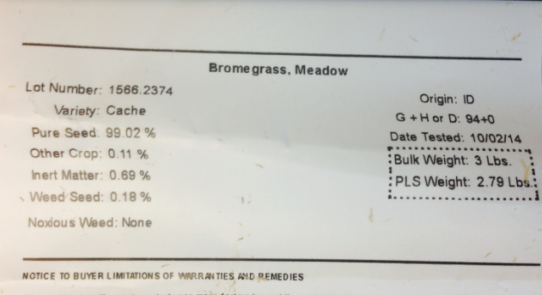

Step 1. We first want to figure out the purity of the seed in the bag. To determine this, we simply subtract the percent other crop, percent innert matter, and percent weed seed from 100.
For this tag, it would look like:
100-.11-.69-.18= 99.02% purity.
As you will notice, this number is already on the seed tag, however, not all seed tags will list this.
Step 2. Next, we need to determine PLS by multiplying that percent purity by the percent germination, and then by 100 as a conversion factor. Also remember to convert your percent’s to decimals, so 99.02% would be .9902.
.9902 (% purity) * .93 (% germination) * 100= 92.08% PLS
You will notice the percent germination was not actually listed on the bag, but we were able to figure it out by dividing the PLS weight (2.79 pounds) by the bulk weight (3 pounds).
Step 3. To figure out how many pounds of PLS we would need to get our desired establishment rates with this bag, we would then divide the recommended seeding rate (usually listed on the tag, for this we’ll use 10 pounds).
10/ .9208 (PLS in decimal form)= 10.9 pounds required at seeding
For this particular bag, there was very high germination rates and low levels of foreign seed, so we didn’t have to increase our seeding rate that much to get the desired number of seeds in the ground. This may not always be the case, which is why knowing how to figure out your PLS rate is extremely important to attain adequate stand establishment.
One final note, just like any other crops, seed size can influence the number of seeds per pound. Bigger seeds means less seeds per pound, and smaller seeds mean more seeds per pound. This is something to be mindful of, and to ask of your seed dealer, when purchasing seed.
For a list of recommended seeding rates, contact myself, Dr. Jessica Torrion, or your local county extension agent. There are also numerous publications available with seeding rate recommendations, such as the “Dryland Pastures in Montana and Wyoming”.
If you have any questions or concerns, please feel free to contact Dr. Emily Glunk at 406-994-5688 or emily.glunk@montana.edu, or Dr. Jessica Torrion at jessica.torrion@montana.edu

